Lab Meeting

Outline

* Paper searching
* Paper progress

Paper searching (1)

J Kennedy *et al*., “Social Robot Tutoring for Child Second Language Learning,” *The Eleventh ACM/IEEE International Conference on Human Robot Interaction,* pages 231-238.

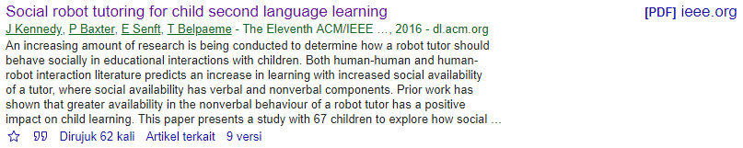

Paper searching (2)

G Gordon *et al*, “Affective Personalization of a Social Robot Tutor for Children’s Second Language Skills,” *Proceedings of the Thirtieth AAAI Conference on Artificial Intelligence (AAAI-16)*.

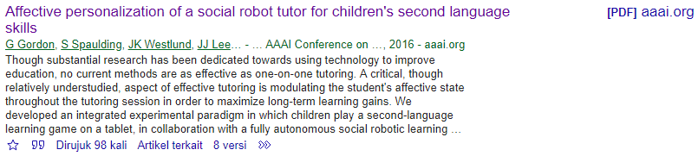

Paper searching (3)

K-Y Chin *et al*, “Impact of Using an Educational Robot-Based Learning System on Students’ Motivation in Elementary Education,” *IEEE Transactions on Learning Technologies*, vol. 7 , issue 4, pages 333 - 345.

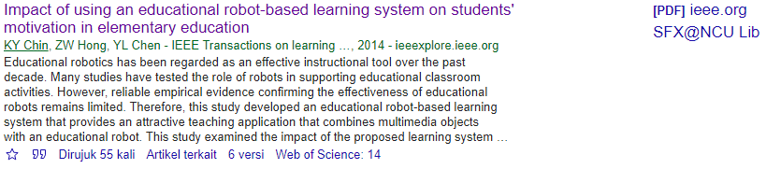

Paper searching (4)

M Fridin, “Storytelling by a kindergarten social assistive robot: A tool for constructive learning in preschool education,” *Computers & Education*, vol. 70, pages 53 – 64.



Paper searching (5)

P Baxter *et al,* “Robot education peers in a situated primary school study: Personalisation promotes child learning,” *Public Library of Science (PLoS Journal) One 12.5 (2017)*.

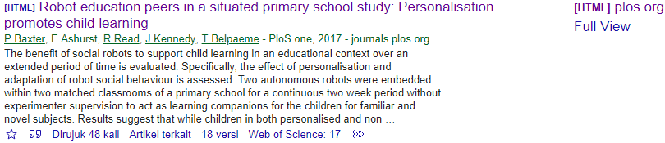

Paper searching (6)

A Sullivan, MU Bers, “Dancing robots: integrating art, music, and robotics in Singapore’s early childhood centers,” *International Journal of Technology and Design Education*, vol. 28, issue 2, page 325 – 346.

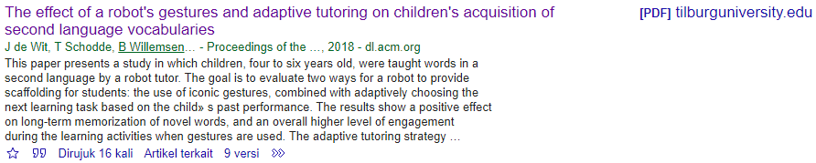

Paper searching (7)

J Kanero *et al,* “Social Robots for Early Language Learning: Current Evidence and Future Directions,” *Child Development Perspectives*, vol. 12, issue 3, pages 146 – 151.



Paper Progress:

* Discuss with prof Tsai:
  + About conference and prof Tsai’s name position at paper, is up to HCI&Learning Lab.
* Discuss with Mahesh:
  + We have plan to submit it to IEEE as soon as possible. So I’m looking for IEEE conference that Last Date of Submission in this year and Conference Dates in early up to middle year of 2020.
  + Place of conference: Asia region.

|  |  |  |  |  |  |  |
| --- | --- | --- | --- | --- | --- | --- |
| **No** | **Name of Conference** | **Place** | **Sponsors** | **Topics** | **Important Date** | **Link** |
| 1 | 2020 22nd International Conference on Advanced Communication Technology (ICACT) | Phoenix Park, PyeongChang,, Korea (South) | Global IT Research Institute - GIRI; IEEE Communications Society | ( as follows, but not limited to )  .  .  14. Industry 4.0, AI, Deep Learning, Big Data, 3D Printer, Game, Search Engine  15. Smart City, M2M, IoT, IoE, ASP, ERP, CRM, SCM  16. Process mining, ICN, EA, GPM, BPM, Work Flow, e-Government, e-Commerce, **e-Learning**, e-Health  17. System, Software, Language, Engineering, Work Method, DataBase  .  . | Abstract Submission : Oct. 10, 2019 **Optional  Full Paper Submission : Oct. 10, 2019  Acceptance Notification : Oct. 31, 2019  Pre-Registration : Nov. 10, 2019  Final CRF Submission : Nov. 25, 2019  Conference Dates: 16 - 19 February 2020 | http://www.icact.org/ |
| 2 | 2020 V International Conference on Information Technologies in Engineering Education ( Inforino ) | Moscow, Russia | Moscow Power Engineering Institute; Russia Section IE/PE/PEL/IA Joint Chapter | Papers in the area of information technologies applied in **engineering education** process are invited with a ​particular emphasis on:   1. Industry 4.0, cybersecurity and engineering education​ 2. Software and Information support and software for engineering education 3. IT in engineering calculations and design of industrial and energy facilities 4. IT in educational, research and testing laboratories​ 5. Distant technologies and electronic educational resources in engineering education​ 6. Computer graphics and 3D modeling in engineering education | 01 Sept - 15​ Nov, 2019 - Full Paper Submission Dates​  30 Dec, 2019 ​- Notification of Acceptance Date  01 Feb, 2020 - Final Paper Submission Date  01 March, 2020 - Fees Transfer Final Date  14 -17​ ​Apr, 2020 - Registration and Conference Work | https://inforino.mpei.ru |
| 3 | 2020 International Conference on Computer Communication and Informatics (ICCCI) | Coimbatore, India | Madras Section; Sri Shakthi Institute of Engineering & Technology | Prospective authors are invited to register and submit the manuscripts of their original research contributions and review articles in the following areas:  *Computer Science (CS)*  …  Artificial intelligence and **robotics**  **Human-computer interaction**  …  *Electronics and Communication (EC)*  ….  *Electrical Engineering (EE)*  …. | Full paper submission deadline: 25, September 2019  Notification of acceptance for other paper: 15, November 2019  Commencement of Conference Registration: 26, December 2019  Conference registration deadline: 10, January 2019  Conference dates: 22 - 24, January 2020 | <http://iccci.in> |
| 4 | 2020 4th International Conference on Intelligent Computing and Control Systems (ICICCS) | Madurai, India | Madras (Coimbatore) Section - ED Chapter; Vaigai College of Engineering | INFORMATICS  ...  INTELLIGNET CONTROL TECHNIQUES  ...  SOFTWARE ENGINEERING  ..  **- Human-Computer Interaction**  ..  MACHINE LEARNING AND OPTIMIZATION  ..  - Robotics and Automation  ..  DATA COMMUNICATION AND COMPUTER NETWORKING  ...  VLSI DESIGN AND AUTOMATION  ... | Paper Submission Due: 4 March, 2020  Paper Acceptance Notification: 4 April, 2020  Last date of registration: 24 April, 2020  Conference Date: 13-15, May 2020 | http://iciccs.com/2020/index.html |
| 5 | 2020 3rd International Conference on Emerging Technologies in Computer Engineering: Machine Learning and Internet of Things (ICETCE) | Jaipur, India | Delhi Section; Swami Keshvanand Institute of Technology - SKIT | MACHINE LEARNING AND APPLICATIONS  ...  **Robotics and Human Machine Interface**  INTERNET OF THINGS (IOT) APPLICATIONS AND TECHNOLOGIES  ...  BIG DATA ANALYTICS  ...  SECURITY, PRIVACY AND TRUST  ... | 30th September, 2019: Last Date of Submission of Paper  15th December, 2019: Notification of Acceptance  31st December, 2019: Last Date of Submitting Camera Ready Copy  15th January, 2020: Conference Registration Deadline (Early Bird)  31st January, 2020: Conference Registration Deadline (with late fee)  07th - 08th February, 2020: Conference Dates | <http://www.icetce.in/2020/index> |
| 6 | 2020 IEEE/ACM 42nd International Conference on Software Engineering (ICSE) | Seoul, Korea (South) | Association for Computing Machinery Special Interest Group on Software Engineering - ACM SIGSOFT; IEEE Computer Society; Korean Institute of Information Scientists and Engineers - KIISE | The Software Engineering Education and Training track seeks research papers and experience reports on all of these aspects of **learning and teaching software engineering**. Topics of interest include but are not limited to:  Foundational research about software engineering skills  Novel methods of teaching software engineering skills  Evaluations of teaching and assessment methods  Empirical studies describing software engineering education contexts  Novel learning technologies that support software engineering education and training  Studies of formal learning contexts such as school or trainings  The role of culture in software engineering education and training | Submissions deadline: 29 October, 2019  Notification of reviewing decisions: 15 January, 2020  Camera ready due: 7 February, 2020  Conference Date: 23 - 29 May 2020 | http://www.icse-conferences.org/ |